PRESS RELEASE

FOR IMMEDIATE RELEASE

Silaturrahim on Eid al-Fitr: A custom shared by ASEAN countries

Kuala Lumpur, Kominfo Newsroom – The ASEAN community in Malaysia has made it a tradition to spend Eid Fitr together, keeping in touch with loved ones and friends, commonly known as silaturrahim.

Wiffy Zalina Putri, a native of West Sumatra, Indonesia, said in Kuala Lumpur on Sunday, 24 April 2023, that when Eid Fitr rolls around, she and her family will pay a visit to all of their relatives' homes, beginning with her father's oldest brother.

Wiffy claims that they customarily drove straight to their uncle's following Eid prayers.

She affirmed that the customary visitation and family reunion will continue till midnight. Sometimes as late as 11 p.m.

According to Wiffy, the family celebrated the second Eid by hosting friends, neighbors, and extended family. They served all the dishes they cooked the day before the celebration.

A little bit different is the perspective of Haidi, an Indonesian from Pamekasan who has been living and working in the Klang Valley for the past seven years. He hasn't started a family yet, so he celebrates Eid Fitr with his friends from back home in Malaysia.

“Nek Lebaran yo podo ngumpul sak koncoan dolan bareng bakar sate pokok e best lah (To hang out with friends and barbecue satay during Eid is the best,” Haidi said.

Given that he only had male friends there, it stands to reason that they didn't prepare any festive meals. They would enjoy satay as a fancy dish.

It's not the same as when you can gather and be with your parents at home. However, celebrating Eid Fitr with friends abroad is preferable to celebrating the holiday on one's own, according to him.

Jamuan Raya, also known as an open house in Indonesia, is a custom commonly observed in Malaysia. The host will throw open the door, and not just to Muslims, but to anyone.

Naturally, guests who come to visit during Eid Fitr will also be spoiled with delicious Eid Fitr dishes.

King Yang di-Pertuan Agong Al Sultan Abdullah of Malaysia hosted a feast celebration on the first day of Eid Fitr 1444 Hijri, immediately following the Eid prayer.

The event was open to everyone from the heads of foreign embassies to Malaysian Prime Minister Anwar Ibrahim and his wife, Deputy Prime Minister Ahmad Zahid Hamidi, and former Malaysian Prime Minister Ismail Sabri Yaakob.

On this occasion, the King and Queen were happy to spend time mingling with all of the guests and their families.

Mimin Mintarsih, an Indonesian originally from Cirebon who has been residing in Malaysia for quite some time, also did the same thing. Even on social media, she let people know when she and her husband would be available to host visitors.

She even has long since baked her own versions of traditional holiday treats like nastar, commonly known as pineapple tart in Malaysia.

During Eid Fitr, many people in ASEAN get together with their families and friends to celebrate and keep in touch with one another.

The similarity in tradition can be leveraged to make Southeast Asia a center of world growth, in line with the theme of the 2023 ASEAN Indonesia Chairmanship, "ASEAN Matters: Epicenter of Growth”. (Virna/ TR/ Elvira)

***

For more information, please contact:

Director General of Public Information and Communications of the Ministry of Communications and Informatics – Usman Kansong (0816785320).

Get other information at https://infopublik.id

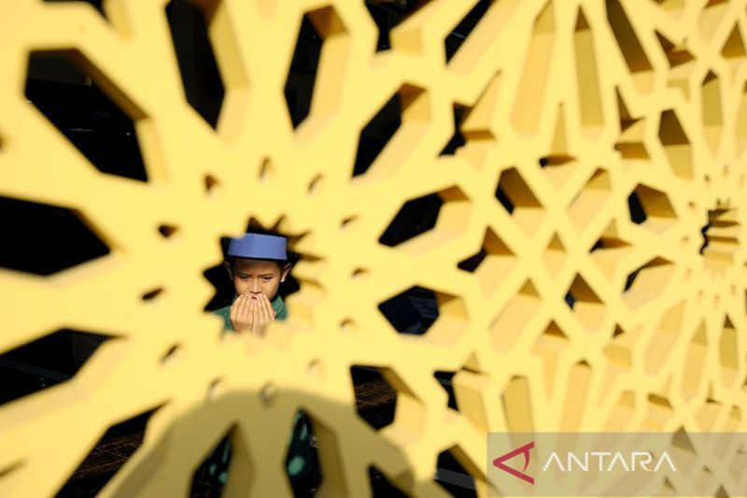

A child prays after observing Eid prayers at the Al-Muhajirin Mosque, Batu Caves, Selangor, Malaysia, Saturday (22 April 2023). ANTARA PHOTO/Rafiuddin Abdul Rahman/nym/pri.

